ICEngineSoft Test Report

Report Date : Sun, Dec 18, 2022 , Time : 1:02:39 PM
Organization : Organisation, Operator : Operator
Data File : 18-12 T50 D50.xlsx, Last Modified Date: Sun, Dec 18, 2022,
Config. File : Kirloskar TV1 Engine.xls

Engine Details :

ICEngine set up under test is Kirloskar TV1 having power 5.20 kW @ 1500 rpm which is 1 Cylinder, Four stroke , Constant Speed, Water Cooled, Diesel Engine, with Cylinder Bore 87.50(mm), Stroke Length 110.00(mm), Connecting Rod length 234.00(mm), Compression Ratio 17.50, Swept volume 661.45 (cc)

Combustion Parameters :

Specific Gas Const (kJ/kgK) : 1.00, Air Density (kg/m^3) : 1.17, Adiabatic Index : 1.41, Polytrophic Index : 1.10, Number Of Cycles : 10, Cylinder Pressure Referance : 6, Smoothing 2, TDC Reference :-1

Performance Parameters :

Orifice Diameter (mm) : 20.00, Orifice Coeff. Of Discharge : 0.60, Dynamometer Arm Legnth (mm) : 185, Fuel Pipe dia (mm) : 12.40, Ambient Temp. (Deg C) : 27, Pulses Per revolution : 360, Fuel Type : Diesel, Fuel Density (Kg/m^3) : 844, Calorific Value Of Fuel (kj/kg) : 43450

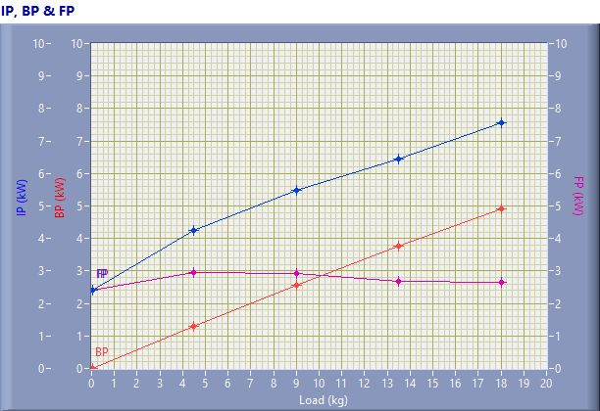

IP, BP & FP

Speed (rpm) | Load (kg) | IP (kW) | BP (kW) | FP (kW)
1592.00 | 0.03 | 2.42 | 0.01 | 2.41
1506.00 | 4.50 | 4.24 | 1.29 | 2.95
1499.00 | 9.01 | 5.48 | 2.57 | 2.91
1464.00 | 13.50 | 6.43 | 3.76 | 2.68
1433.00 | 18.02 | 7.56 | 4.91 | 2.65

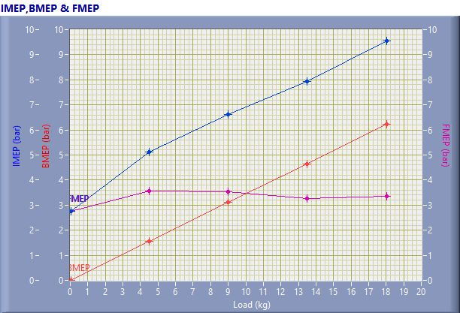

IMEP,BMEP & FMEP

Speed (rpm) | Load (kg) | IMEP (bar) | BMEP (bar) | FMEP (bar)
1592.00 | 0.03 | 2.76 | 0.01 | 2.75
1506.00 | 4.50 | 5.11 | 1.55 | 3.56
1499.00 | 9.01 | 6.63 | 3.11 | 3.52
1464.00 | 13.50 | 7.92 | 4.66 | 3.26
1433.00 | 18.02 | 9.57 | 6.21 | 3.35

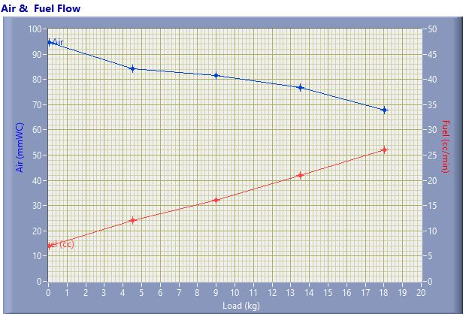

Air & Fuel Flow

Speed (rpm) | Load (kg) | Air (mmWC) | Fuel (cc/min)
1592.00 | 0.03 | 94.53 | 7.00
1506.00 | 4.50 | 84.08 | 12.00
1499.00 | 9.01 | 81.52 | 16.00
1464.00 | 13.50 | 76.73 | 21.00
1433.00 | 18.02 | 68.00 | 26.00

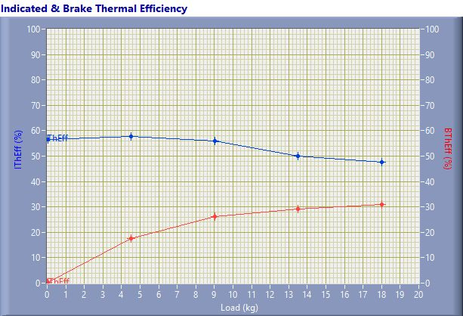

Indicated & Brake Thermal Efficiency

Speed (rpm) | Load (kg) | IThEff (%) | BThEff (%)
1592.00 | 0.03 | 56.63 | 0.23
1506.00 | 4.50 | 57.82 | 17.57
1499.00 | 9.01 | 56.01 | 26.25
1464.00 | 13.50 | 50.14 | 29.27
1433.00 | 18.02 | 47.55 | 30.89

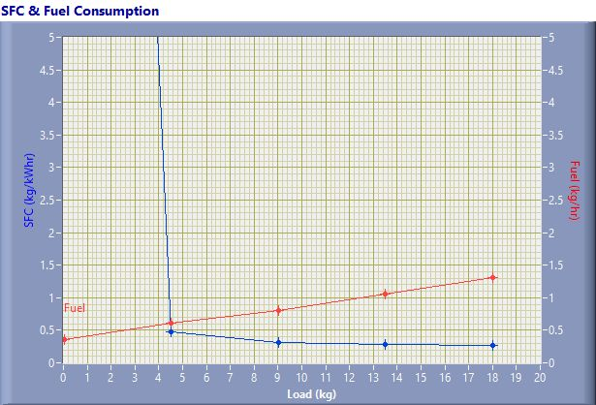

SFC & Fuel Consumption

Speed (rpm) | Load (kg) | SFC (kg/kWh) | Fuel (kg/h)
1592.00 | 0.03 | 36.61 | 0.35
1506.00 | 4.50 | 0.47 | 0.61
1499.00 | 9.01 | 0.32 | 0.81
1464.00 | 13.50 | 0.28 | 1.06
1433.00 | 18.02 | 0.27 | 1.32

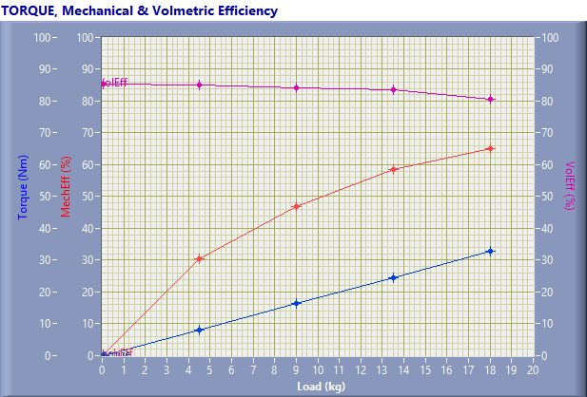

TORQUE, Mechanical & Volmertic Efficiency

Speed (rpm) | Load (Kg) | Torque (Nm) | Mech Eff. (%) | Vol Eff. (%)
1592.00 | 0.03 | 0.06 | 0.40 | 85.38
1506.00 | 4.50 | 8.17 | 30.39 | 85.12
1499.00 | 9.01 | 16.35 | 46.87 | 84.21
1464.00 | 13.50 | 24.50 | 58.38 | 83.65
1433.00 | 18.02 | 32.71 | 64.96 | 80.45

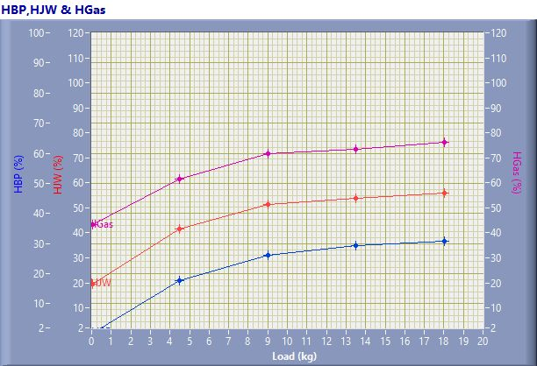

HBP,HJW & HGas

Speed (rpm) | Load (kg) | HBP (%) | HJW (%) | HGas (%) | HRad (%)
1592.00 | 0.03 | 0.23 | 19.36 | 23.68 | 56.73
1506.00 | 4.50 | 17.57 | 24.00 | 20.01 | 38.42
1499.00 | 9.01 | 26.25 | 25.19 | 20.16 | 28.40
1464.00 | 13.50 | 29.27 | 24.49 | 19.69 | 26.55
1433.00 | 18.02 | 30.89 | 24.90 | 20.45 | 23.76

Observation Data

Speed (rpm) | Load (kg) | Comp Ratio | T1 (deg C) | T2 (deg C) | T3 (deg C) | T4 (deg C) | T5 (deg C) | T6 (deg C)
1592 | 0.03 | 17.50 | 38.47 | 43.20 | 38.47 | 37.69 | 130.55 | 104.84
1506 | 4.50 | 17.50 | 38.55 | 48.61 | 38.57 | 39.91 | 184.61 | 140.41
1499 | 9.01 | 17.50 | 38.63 | 52.70 | 38.63 | 42.35 | 240.54 | 178.54
1464 | 13.50 | 17.50 | 38.69 | 56.65 | 38.69 | 45.45 | 306.53 | 224.10
1433 | 18.02 | 17.50 | 38.77 | 61.39 | 38.77 | 49.86 | 397.16 | 281.30

Observation Data

Air (mmWC) | Fuel (cc/min) | WaterFlow Engine (lph) | WaterFlow Cal (lph)
94.53 | 7.00 | 150 | 75
84.08 | 12.00 | 150 | 75
81.52 | 16.00 | 150 | 75
76.73 | 21.00 | 150 | 75
68.00 | 26.00 | 150 | 75

Result Data

Torque (Nm) | BP (kW) | FP (kW) | IP (kW) | BMEP (bar) | IMEP (bar) | BTHE (%) | ITHE (%) | Mech Eff. (%)
0.06 | 0.01 | 2.41 | 2.42 | 0.01 | 2.76 | 0.23 | 56.63 | 0.40
8.17 | 1.29 | 2.95 | 4.24 | 1.55 | 5.11 | 17.57 | 57.82 | 30.39
16.35 | 2.57 | 2.91 | 5.48 | 3.11 | 6.63 | 26.25 | 56.01 | 46.87
24.50 | 3.76 | 2.68 | 6.43 | 4.66 | 7.92 | 29.27 | 50.14 | 58.38
32.71 | 4.91 | 2.65 | 7.56 | 6.21 | 9.57 | 30.89 | 47.55 | 64.96

Result Data

Air Flow (kg/h) | Fuel Flow (kg/h) | SFC (kg/kWh) | Vol Eff. (%) | A/F Ratio | HBP (%) | HJW (%) | HGas (%) | HRad (%)
31.66 | 0.35 | 36.61 | 85.38 | 89.32 | 0.23 | 19.36 | 23.68 | 56.73
29.86 | 0.61 | 0.47 | 85.12 | 49.14 | 17.57 | 24.00 | 20.01 | 38.42
29.40 | 0.81 | 0.32 | 84.21 | 36.29 | 26.25 | 25.19 | 20.16 | 28.40
28.53 | 1.06 | 0.28 | 83.65 | 26.83 | 29.27 | 24.49 | 19.69 | 26.55
26.86 | 1.32 | 0.27 | 80.45 | 20.40 | 30.89 | 24.90 | 20.45 | 23.76

